Realogy Advantage Broker Network

Coldwell Banker Wallace is a member of the largest Broker Network in the United States. By being a part of Realogy Advantage Broker Network, CBW is afforded the opportunity to work with some of the best top performing companies. Each company is held accountable with strict requirements on delivering great service, timeliness, professionalism and responsiveness. We guarantee your client the best service available. If for any reason your client is unsatisfied with the service that he/she is receiving, we can have your client reassigned with no questions asked! So, whether your client is buying or selling, we have it covered with our trusted network of agents.

Agent Benefits

- Your client will be connected to a relocation trained professional.
- This is service you can offer to your clients, friends and family, not in your local area.
- Fast and easy way for you to earn additional CASH.
- Referral fees are guaranteed through the Realogy Advantage Broker Network.

What is an Outgoing Referral?

An outgoing referral is a real estate transaction that takes place outside of our service area. Examples are:

- A person relocating from one city to another. Ex. Moving from Atlanta, GA to Denver, CO. This could create two outgoing opportunities; a listing in Atlanta and a home find in Denver.
- A person is moving from our service area to a location outside of our area. Example: Moving from Knoxville to Nashville.
- Anyone needing assistance to purchase or to sell property outside of our service area. Example: Your brother is selling his home in Memphis, and then buying another in Memphis.
How to Place Outgoing Referrals

Outgoing Referrals must be submitted to Referral Connections
through the E-Relocation on-line link.

The link is accessible through connectcbw.com – buyer and seller tools- e-relocation – outgoing referrals.

Please provide the most complete information on the customer possible.
Required Information*: (Everything with a red asterisk is required)
* Customer’s Permission
* Customer’s Name
* Current Address (Please include property address if different)
* Contact numbers (Cell, work, home. We must have at least one phone number)
* Email address
* Location/City (If referral is a home purchase)
* Property Criteria
* Price Range
* House finding trip dates

Once your outgoing referral has been placed, you will receive confirmation via email with the name and contact information of the agent your client has been placed with. It is important to make contact and introduce yourself to the assigned agent within 24 hours and maintain regular contact until the transaction has closed.

Important Fact to Remember

We strive to place all outgoing referrals with Brokers who are members of the Realogy Advantage Broker Network. Please keep in mind, that not all are Coldwell Banker but also Century 21, ERA, Sotheby’s, Better Homes & Gardens, and in some cases independent Brokers.
Tips on Generating Outgoing Referrals

- Listings are a great source. Always ask where your clients are moving, when they are moving and if they would like information on their new destination.

- Relatives and friends often know someone moving or they may be moving themselves. They do not have to be moving into or out of your service area.

- Target FSBOs. Use our referral services as a good initial contact. They can receive information on their new city at no cost or obligation. Remember you are offering them a service.

- Open Houses – Always ask where the client is moving from?

Steps to Success

- Never send a referral unless the client has given permission to be referred
- Explain the services offered to your client
- Call your client within 2 days to make sure they have been contacted and are satisfied. Report any issues to Referral Connections
- Continue to stay in touch with both the client and the receiving agent until a successful transaction is complete

Referral Connections
Coldwell Banker Wallace
(865) 694-1415 office
Carol Hart – Director of Referral Connections x-1601
Susan Reynolds – Referral Coordinator x-1602
Email: chart@cbww.com

CBW
Referral Connections
Outgoing Referrals
Quick Reference

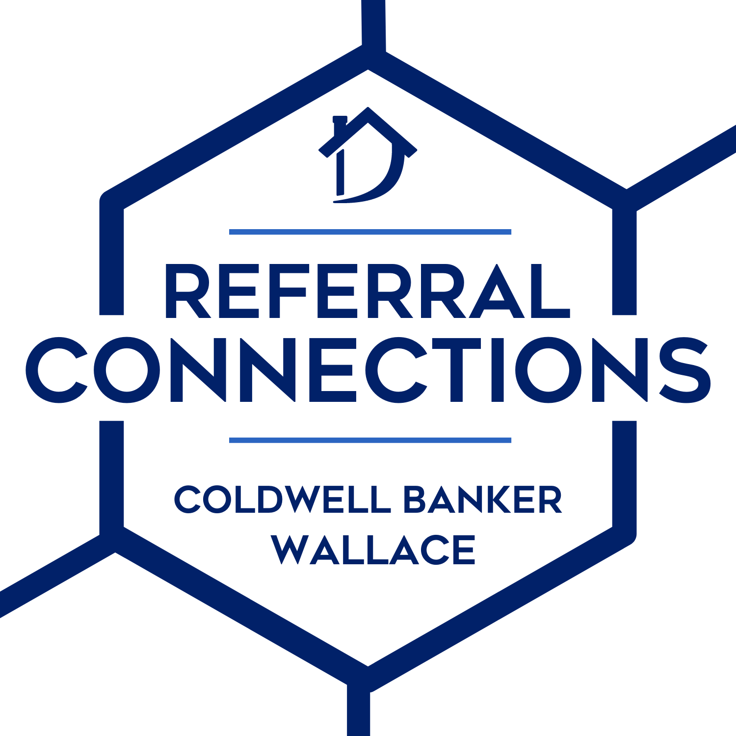

The Benefits of
Realogy Advantage
Broker Network

