HOW TO FIND AN OPEN HOUSE TO HOST!
- Ask agents in your office.
- Ask your Broker.
- Only Host CBW listings!
- Search the MLS for CBW listings. Here’s How!
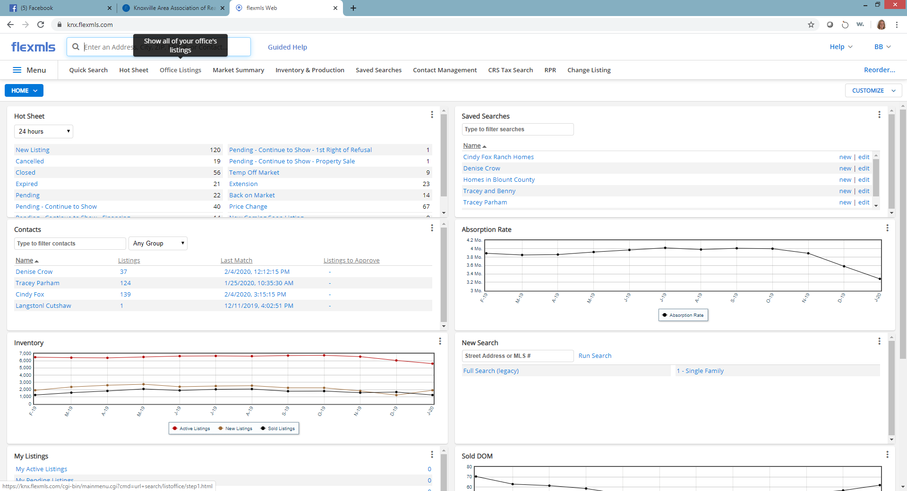
Click on the TAB that says OFFICE LISTINGS
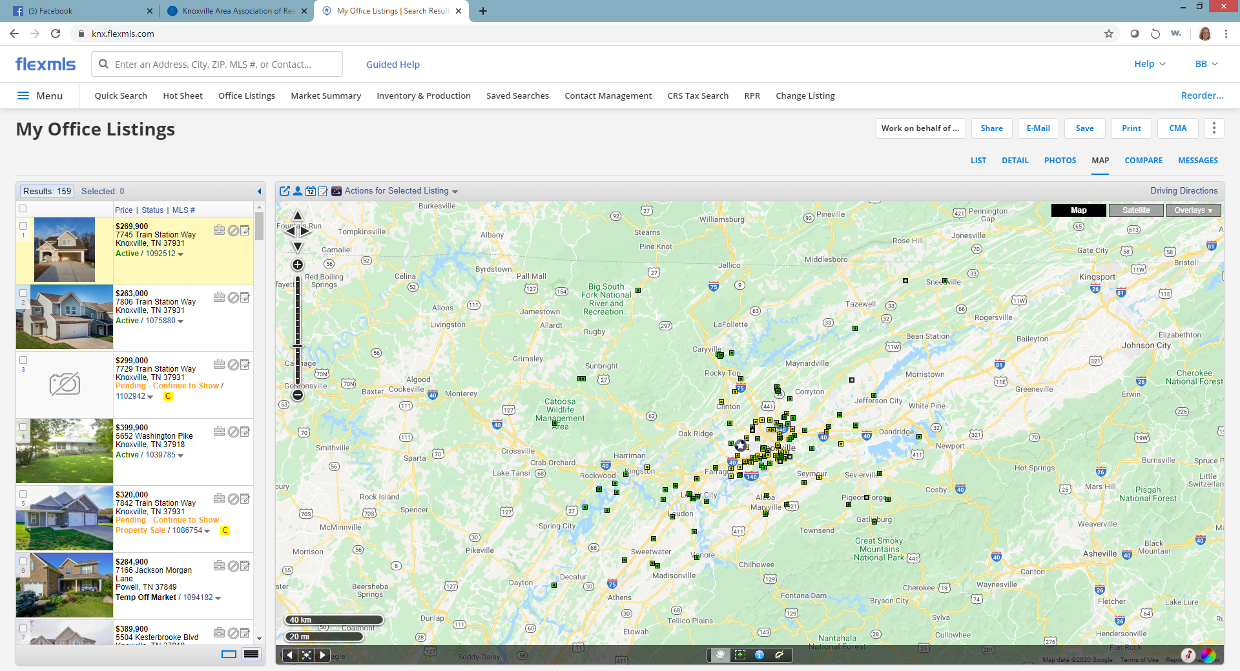Page One
Click on the TAB that says MAP
With the map view you can see all of the areas and you can select an area that you would want to work!
Click once on the green dots (these are the active listings) When you click on the green dots a small white box will pop up and you will see the price for this listing. (See Below)

TIPS: Select homes that are close to main roads. If someone has to turn 15 times from a main road, you may lose them, plus you have to put out so many more open house signs!
Our recommendation for listing price is: $150,000 - $300,000. You can go higher or lower, completely up to you.
Only host new construction if the home is nearly complete and HVAC is working.
Always put out signs! Consider purchasing the permanent balloon or flags.

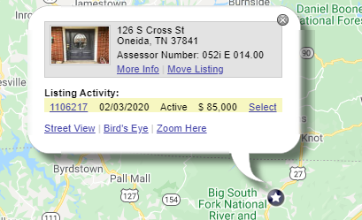
You can click on the listing number to open the detail page of the listing. When you do this, a new page (tab) opens in your browser, to get back to the map page, close this page (tab).

Once you have the Detail Page on your screen, you can read through it, look at the pictures, see how long it has been on the market and see the name and number of the listing agent.

Once you find a home you would like to host:
- Call the Listing Agent and ask if the seller would be interested in allowing an agent to host an open house.
- Select a Date and Time
- Determine who will put out Open House signs.
- Prepare your bag with all the items (ideas) discussed in this class. Do not wait until Sunday morning!
- Arrive early, turn on lights, unlock doors, pick up/straighten up anything out of place.
- Your safety is most important, if uncomfortable with someone who has shown up, leave the house.
- Know your comps! Study nearby sales and know what is on the market. (see page 3)
- Lock up and leave the home the way you found it.
- CALL THE LISTING AGENT and let them know how many guest you had.

Page Two
VALUABLE INFORMATION TO TAKE WITH YOU WHEN HOSTING AN OPEN HOUSE!

>People tour Open Houses because they are nosey or because they think they may want to live in that area.
>If each guest fell in love with the home you are hosting, that would be fantastic, however, what do you do if they don’t like the house? Are you ready with additional information?? You need to be! Here’s how.

Start with the Address of the listing you are hosting: (Example: 7732 Sabre Drive) In the Quick Search box at the very top type in the address of the listing
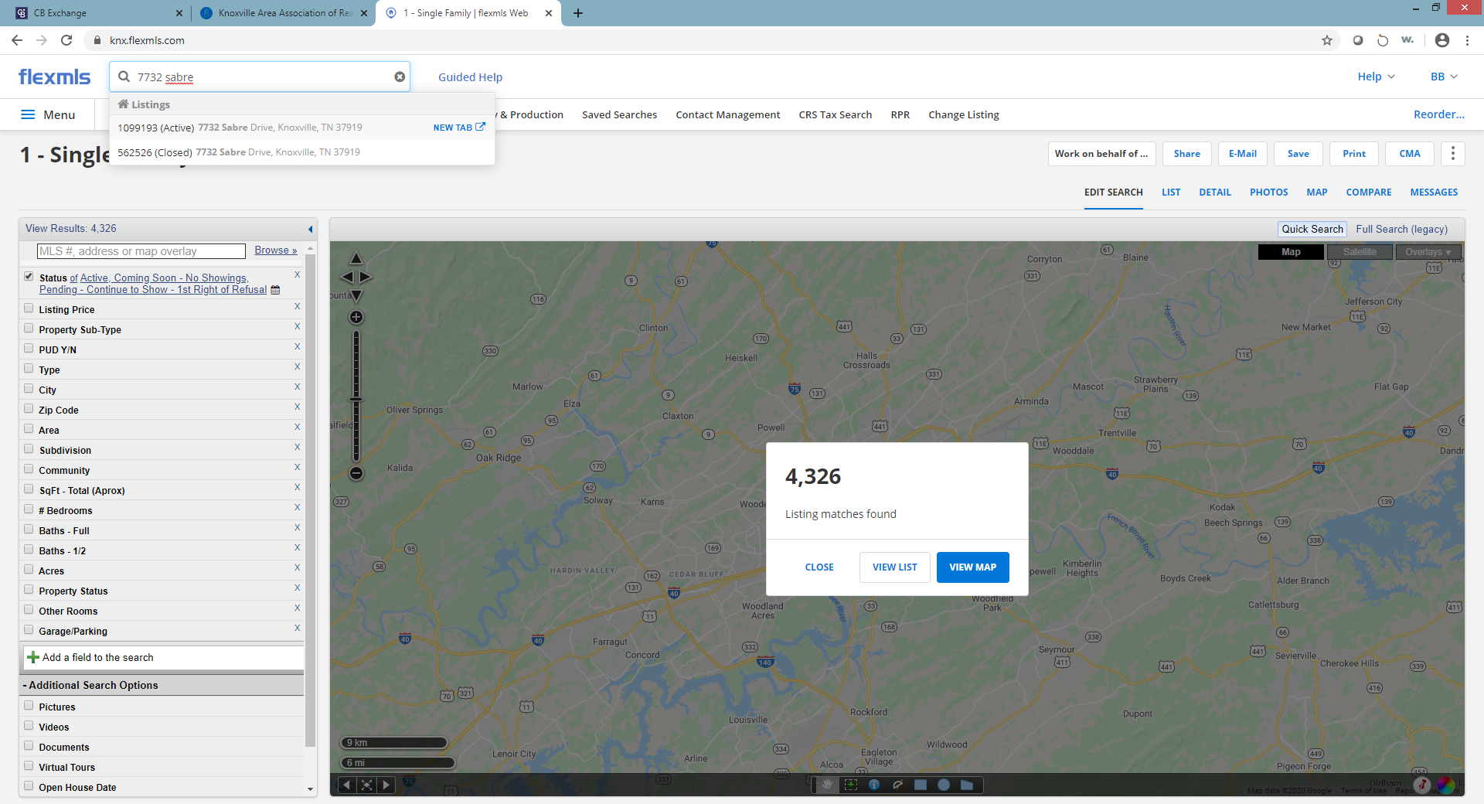
Once the listing Detail page is on your screen, click on the word MAP, see below.
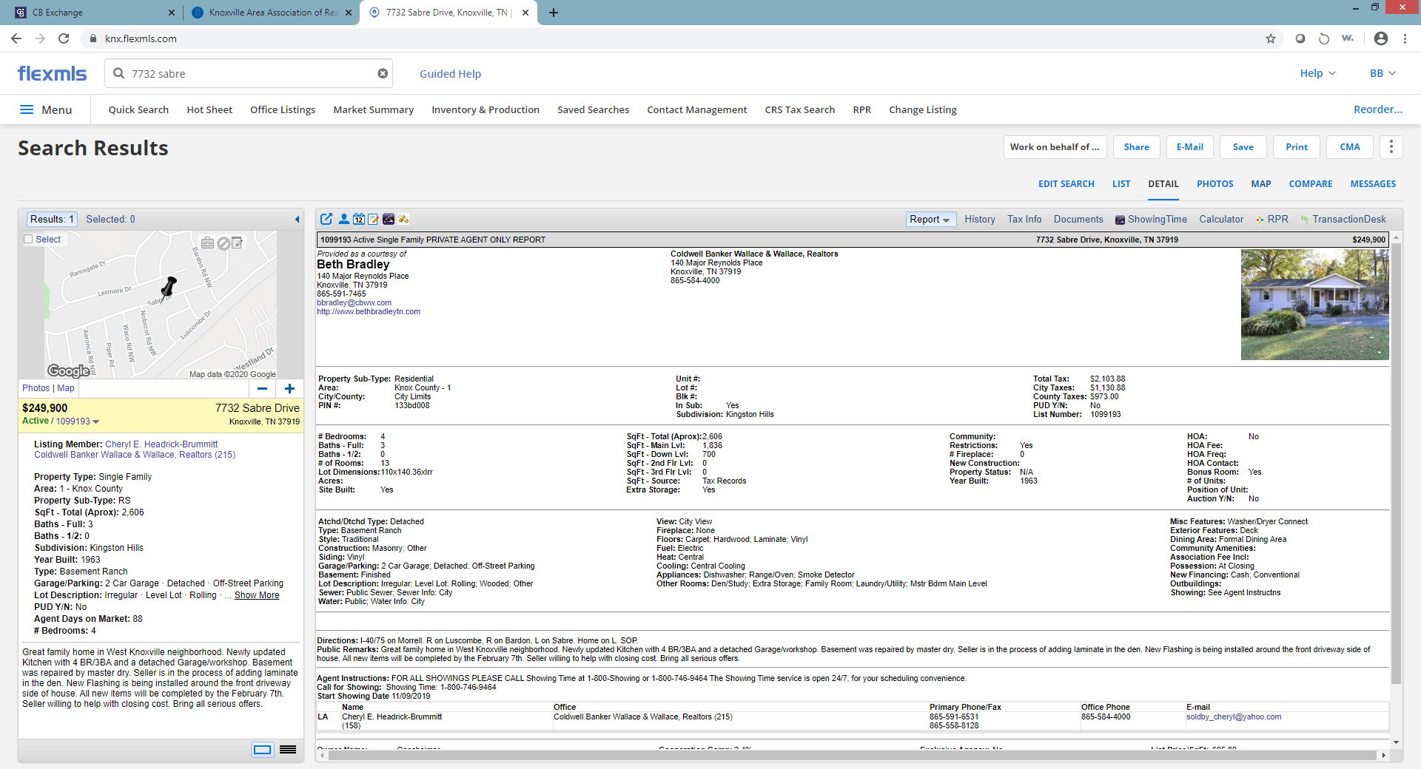
Page Three
Now you should be looking at the map location of the listing. At the bottom of the map, there are three shapes, I would either select the circle or the polygon. Click and drag from the location of the house approximately a 1 – 2 miles radius.
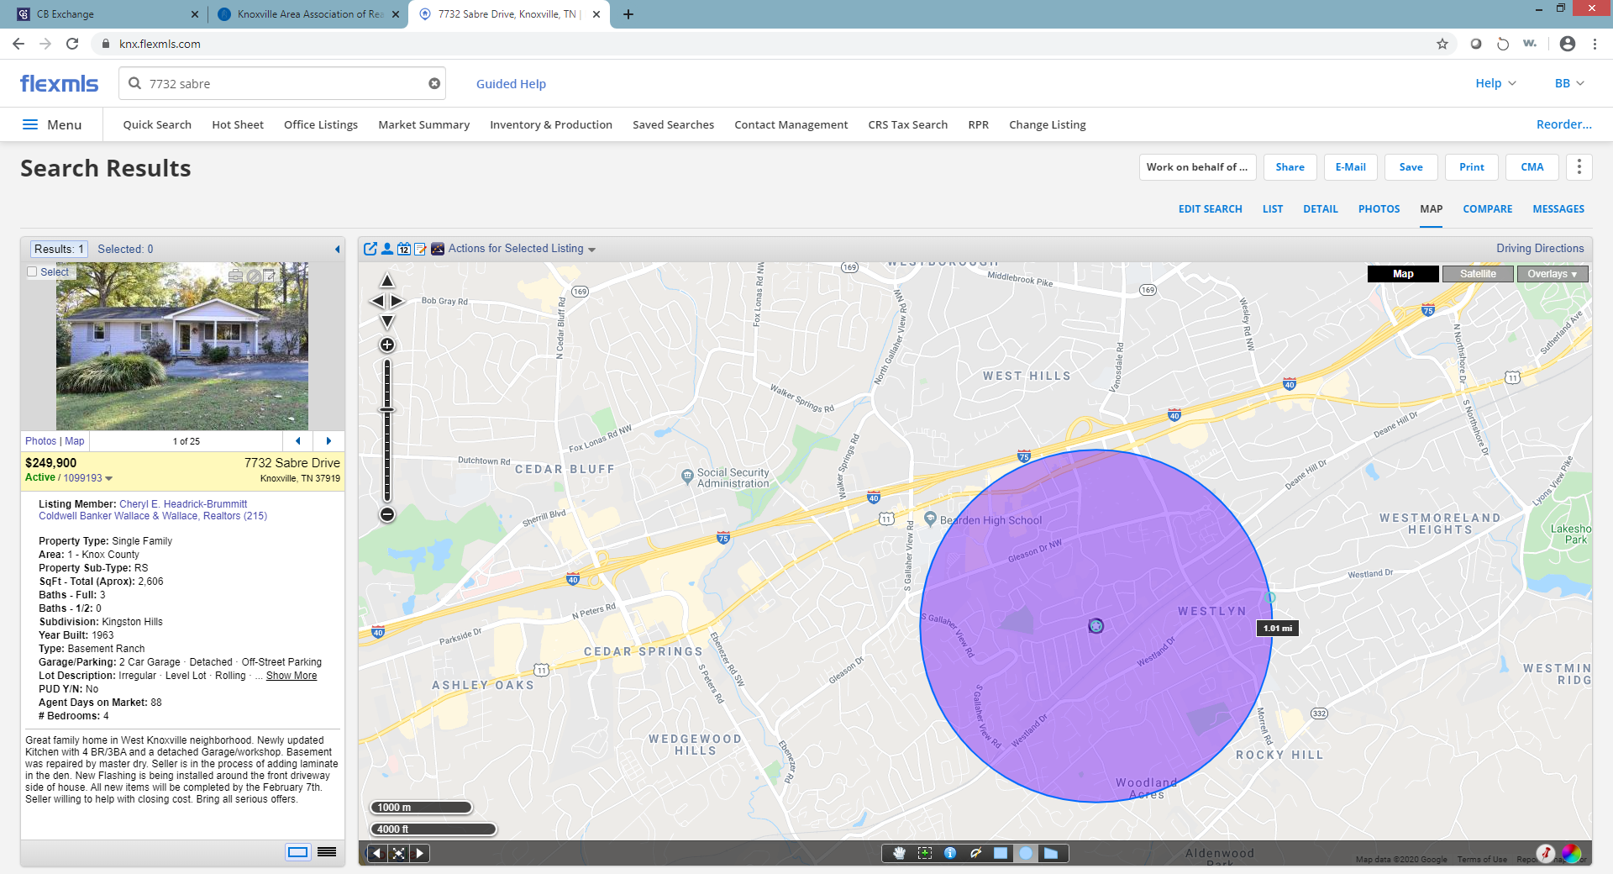
THE WHOLE IDEA is to find the homes nearby that are for sale. We can only assume that if they drove to this home to tour an Open House, they are wanting a home in that area.

NOW – THIS IS IMPORTANT! Uncheck the box in the Edit Panel on the left that has the MLS number. A whole lot of listings will start to populate. We need to narrow it down!

In the box that says Add a Field, type in:

Status: click the word status in the right column, now select Active. You can add in the pendings if you want for informational purposes.
Listing Price: click the word Listing Price in the right column, now enter a range around the home you will be hosting.
(example: home you are hosting is $225,000, your price range would be $200,000 - $250,000)

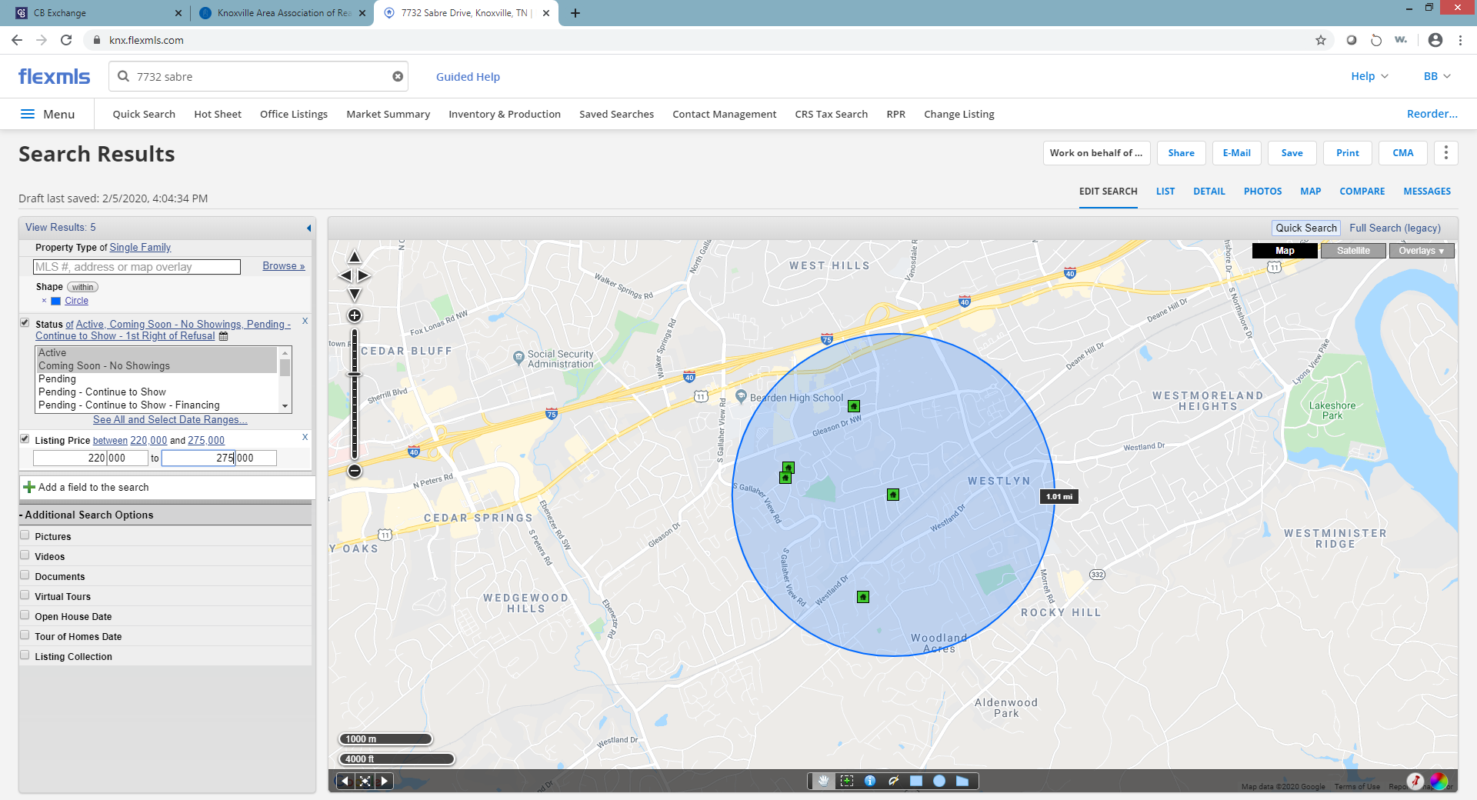
What is left on the map are the homes within a mile or two from the listing and are within the price range the buyer may afford.
Page Four
The LAST STEP is to prepare the packets for potential buyers!

On the last page with the Map, there is a tab at the top right that says PRINT, click Print. MAKE SURE THE CIRCLE BUTTON THAT SAYS “ALL RESULTS” IS CHECKED!!

Now, print out all the forms in the Private Format first, this is YOUR copy.

Then print out all the forms in the Public Format, this will be copies for people who come to the Open House.

When printing your packets, put the home you are hosting on TOP and print them in black and white – no need to waste color ink. Once you have your sets (approximately 12 – 15 sets), print out IN COLOR, the flyer that says “I CAN SHOW YOU ANY HOME ON THE MARKET”.

Page Five

